**FIT – Barcelona 5 nights**

**day 1**

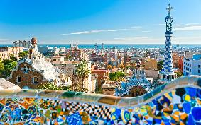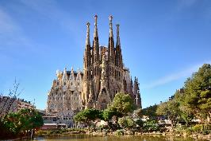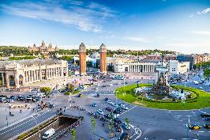

**private transfer** from Barcelona airport to the hotel in Barcelona.

**leisure time** to enjoy the city. shopping, could be your first option in Barcelona or you could watch a football game.

overnight at hotel in Barcelona.

**day 2**

breakfast at the hotel.

**Barcelona sightseeing** based on a hop on hop off city tour.

*highlights of the two different tours are:*

***the gothic cathedral****, which has always been the heart of the city, located in the very downtown and flanked by the remains of the city walls.*

***the Olympic Barcelona*** *is spread all over the city. on the one hand side the Olympic port and the Olympic Village are located on the Barceloneta, on the other hand the Olympic ring and the stadiums are located on the Montjuïc hill.*

***Sagrada Familia****, Gaudi’s greatest work and undoubtedly Barcelona’s most identifiable monument and* ***Montjuïc hill****, a dominant feature of the city’s skyline.*

***Passeig de Gràcia****, with the highest concentration of modernist buildings in the city. among others, enjoy an outside view of Antoni Gaudi’s Casa Batlló and Casa Milà.*

overnight at hotel in Barcelona.

**day 3**

breakfast at the hotel.

half day **Montserrat sightseeing** based on regular basis.

*Montserrat, an imposing rocky outcrop, is the holy mountain of Catalonia, which houses the revered image of the black virgin.*

overnight at hotel in Barcelona.

**day 4**

breakfast at the hotel.

**leisure time**, enjoy the weather and cuisine in this charming and cosmopolitan city. find little gems in the city like the Poble Espanyol (a traditional Spanish village in miniature) and Plaza del Born.

overnight at hotel in Barcelona.

**day 5**

breakfast at the hotel.

day at **leisure** to discover the city by oneself. the day could be spent in the port Aventura amusement park, touring the stadium of Barça or enjoying a traditional flamenco show.

overnight at hotel in Barcelona.

**day 6**

breakfast at the hotel.

**private transfer** from the hotel to Barcelona airport.

**end of services**

**prices**

|  |  |  |  |
| --- | --- | --- | --- |
| **price per person & package** | **Nov - Mar** | **Apr - Oct** | **Jul - Aug** |
| **standard class** | **389 €** | **486 €** | **486 €** |
| child standard price (up to 8 yrs) | **282 €** | **276 €** | **276 €** |
| single supplement | **208 €** | **287 €** | **287 €** |
| **first class** | **433 €** | **527 €** | **527 €** |
| child first price (up to 3 yrs) | **270 €** | **311 €** | **311 €** |
| single supplement | **228 €** | **310 €** | **310 €** |
| **superior class** | **481 €** | **665 €** | **572 €** |
| child superior price (up to 11 yrs) | **42 €** | **42 €** | **42 €** |
| single supplement | **278 €** | **426 €** | **349 €** |

* prices per person based on double room & bb basis. taxes included. valid for minimum 2 traveling pax. prices for children sharing room with 2 adults.

* prices subject to availability and possible fluctuations in any of the requested services at the time of final booking.

**validity**: **until October 2020**

inclusions:

|  |  |  |  |  |
| --- | --- | --- | --- | --- |
| **city & nights** | **transfers** | **Sightseeing on SIC basis** | **meals** | **24h. phone**  **assistance** |
| **5n Barcelona** | private  apt-htl-apt | hop on hop off  one day ticket  half day excursion  to Montserrat | breakfast |

price does not include:

* bus, train or flight tickets.
* regional tourist tax.
* tips or guests’ extras.
* any other service not mentioned on the programme / itinerary described.
* **transportation to sightseeing meeting points is not included, we recommend the use of public transportation or taxi.**

**optional supplements**:

|  |  |  |
| --- | --- | --- |
| C:\Users\marketing2\Downloads\camp-nou.jpg  **football tickets**  **on request** (prices average 48-250 €) | C:\Users\marketing2\Downloads\Camp02.jpg  **Barça – Camp Nou stadium tour**  adult: 26 € child (6-13): 21 €  *\*with time and date given* | C:\Users\marketing2\Downloads\tablao cordobes.jpg  **flamenco show & dinner in Barcelona**  adult, from: 50 € (vegetarian menu available) |
| C:\Users\marketing2\Downloads\c700x420.jpg  **Port Aventura amusement park**  prices from: 59 € adult and 50 € child (4-10) |  |  |

**\*** prices per person.